**T. Y. B. Tech (Electrical and Computer Engineering)**

**Trimester: VI Subject: Electric vehicle technology**

**Name: Shreerang Mhatre Class: TY BTECH EL&CE**

**Roll No: 52 Batch: A2**

**Experiment No: 06**

**Name of the Experiment:** To simulate and analyze the operation of a single-phase PWM inverter for EV testing in MATLAB

**Marks**

**Teacher’s Signature with date**

**Performed on Submitted on**

**Aim:** To understand simulation of inverters for EV

**Resources:** Matlab 2022, Simscape toolbox

# Theory:

PWM inverters convert DC power into AC power by switching the DC input in a controlled manner to generate an AC output waveform.

Pulse Width Modulation (PWM) is a technique where the width of the pulses in the output waveform is varied in proportion to the amplitude of a modulating signal.

In single-phase PWM inverters, typically, a bridge configuration (like H-bridge) is used, where switches are turned on and off in a controlled manner to generate the desired AC waveform.

**Procedure:**

Design the PWM inverter circuit: This involves selecting appropriate components such as switches (e.g., IGBTs), diodes, and filters.

Choose PWM control strategy: Common strategies include Sinusoidal PWM (SPWM), Space Vector PWM (SVPWM), and Third Harmonic Injection PWM (THIPWM).

Implement the chosen PWM control strategy in simulation software (e.g., MATLAB/Simulink, LTSpice, PLECS).

Simulate the PWM inverter circuit with the chosen control strategy.

Analyze the simulation results to assess the performance of the PWM inverter, including output waveform quality, efficiency, and harmonic distortion.

**Simulation Setup:**

Use MATLAB's Simulink or scripts to set up the simulation environment. Model the single-phase PWM inverter circuit including the DC input source, switching devices (IGBTs or MOSFETs), output filter, and load.

Implement the chosen PWM control strategy using appropriate blocks or functions in the simulation software.

Set up simulation parameters such as DC input voltage, modulation index, switching frequency, and load impedance.

**Simulation Execution:**

Model the single-phase PWM inverter circuit including the DC input source, switching devices (IGBTs or MOSFETs), output filter, and load.

Implement the chosen PWM control strategy using appropriate blocks or functions in the simulation software. Set up simulation parameters such as DC input voltage, modulation index, switching frequency, and load impedance.

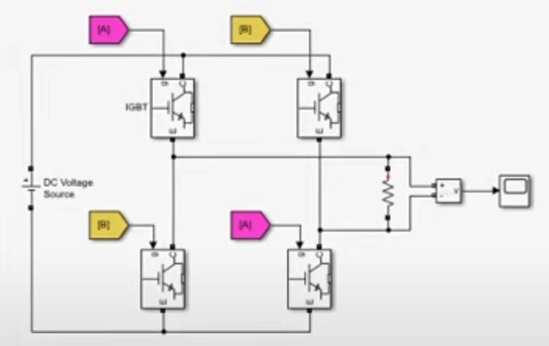

Fig 1.1 :Single Phase inverter Model

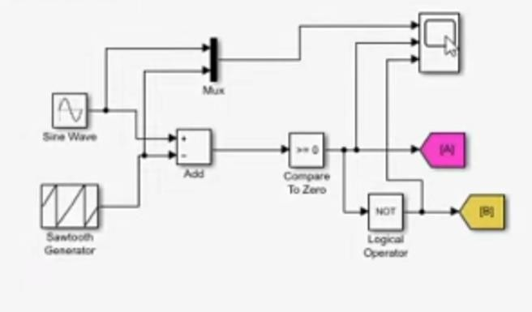

Fig 1.2 :Bipolar PWM model

**Analysis and Visualization:**

Analyze simulation results to evaluate EV performance metrics such as efficiency, range, and energy usage. Plot graphs, generate reports, and compare different scenarios to assess and optimize the EV system

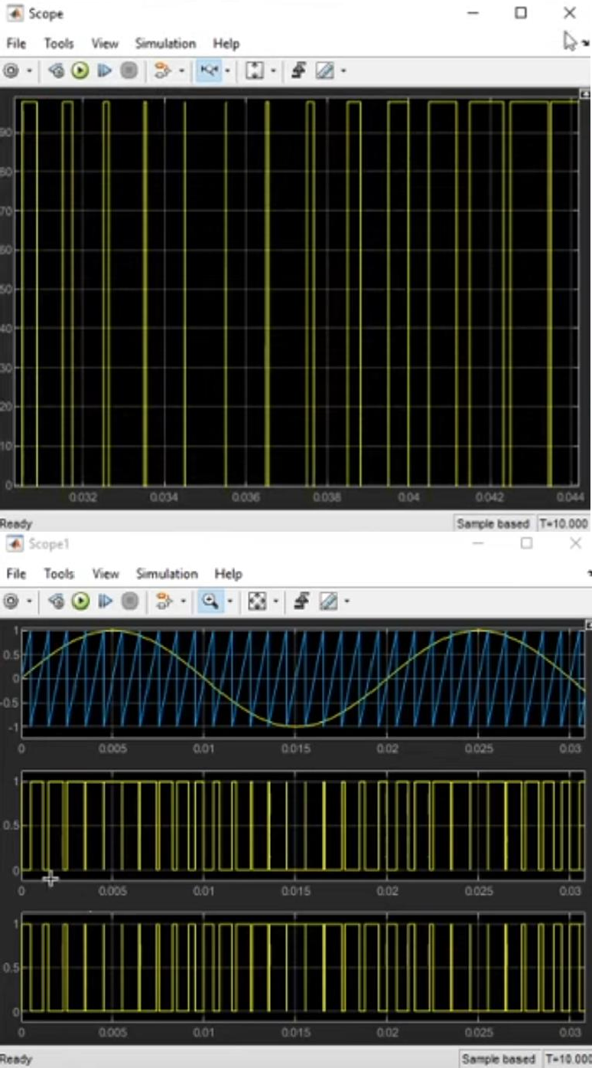

**Reference link https://**[**www.youtube.com/watch?v=q7iV9wh90-o**](http://www.youtube.com/watch?v=q7iV9wh90-o)

**Conclusion-** In conclusion, simulating a single-phase PWM inverter offers a detailed understanding of its operation and performance. By analyzing simulation results, we can assess efficiency, waveform quality, and identify areas for improvement, aiding in the design and optimization of PWM inverter systems.